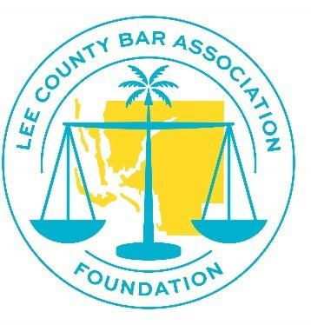
LEE COUNTY BAR ASSOCIATION FOUNDATION, INC.
Grant Applicant Consent/Objection to Publicity Form

I, (printed name), the undersigned (“Applicant”) have applied or intend to apply to the Lee County Bar Association Foundation, Inc. (the “LCBA
Foundation”) for a Grant.
- I understand that the LCBA Foundation normally discloses:
  - the names of its Grant recipients,
  - the fact that they have been awarded a Grant,
  - the amounts of their Grant award,
  - the purpose of the Grant award,
  - the activities of the organization receiving the Grant,
  - the application they submitted when they applied for the Grant,
  - and their photographs.

- I also understand that, unless I object below on this form, the LCBA Foundation will or may publicize the foregoing information in various ways, including: newsletters and magazines published by, for or on behalf of the Lee County Bar Association, Inc. (“LCBA”) or the LCBA Foundation; to the members, sponsors, friends and employees of the LCBA or the LCBA Foundation; on the LCBA or the LCBA Foundation’s website, social media pages (e.g., Facebook, Instagram, Twitter); on any other social media published by either the LCBA or the LCBA Foundation; via press releases by either the LCBA or LCBA Foundation; and to past and potential donors or recipients. Such publication may be in any format or in any type of media, including, but not limited to, print, online, television, radio, or social media.

- Any publication by the LCBA and LCBA Foundation will be for non-profit, non- commercial purposes only, and I understand that I will not be compensated for any such disclosure, dissemination or publication. I understand that, even if I object to all disclosures and publicity, the LCBA Foundation may still disclose the grant recipient’s name, amount of the grant, and purpose of the grant on its IRS Form 990, which is a public document.

- Finally, I understand that a decision to object to some or all such disclosures and publicity is not a disqualification for a Grant award.

Understanding all of the foregoing, I hereby:

consent to all such disclosures and publicity.
object to disclosure and publication of only

object to all such disclosures and publicity.
Applicant Signature:

Date:

